COMPILER CONSTRUCTION

LAB MID TERM

Name: Furqan Ahmed

Reg No: Sp20-bcs-052

Date: 05-04-2024

**QUESTION NO 1:**

Briefly describe the regex library of C#.

**Answer:**  
 The regex library in C# provides powerful tools for working with regular expressions. It allows you to define patterns and search, replace, or manipulate strings based on those patterns. C# regex supports a wide range of features including character classes, quantifiers, groupings, alternations, anchors, and more. It offers methods like ‘**Regex.Match’**, ‘**Regex.Replace’**, ‘**Regex.Split’** etc. for performing operations on strings using regular expressions. Additionally, it supports options for case sensitivity, multiline mode, and culture-specific behavior. Overall, it's a versatile and efficient tool for text processing tasks in C#.

**QUESTION NO 2:**

Make recursive descent or LL1 parser or recursive descent parser for the following grammar:

S -> X$

X -> X % Y |Y

Y -> Y & Z |Z

Z -> k X k | g

**Solution:**

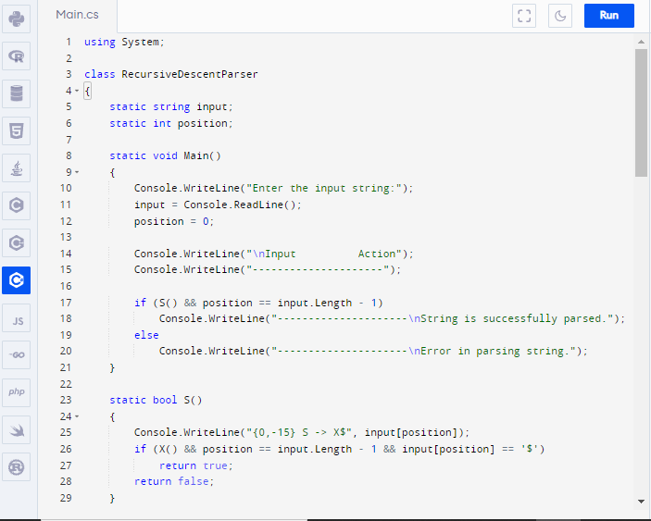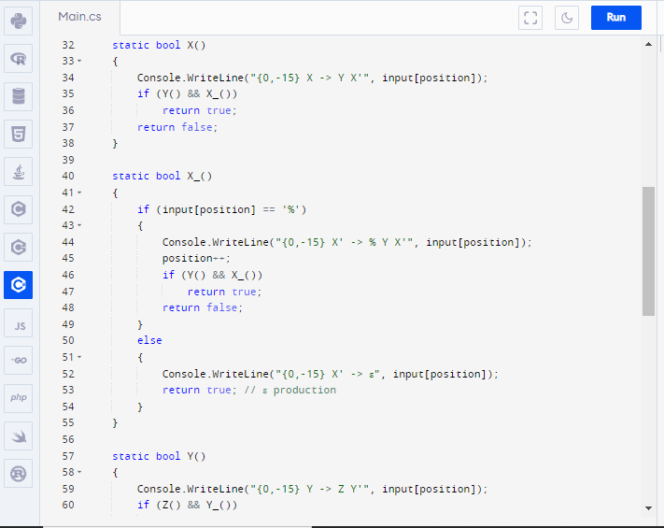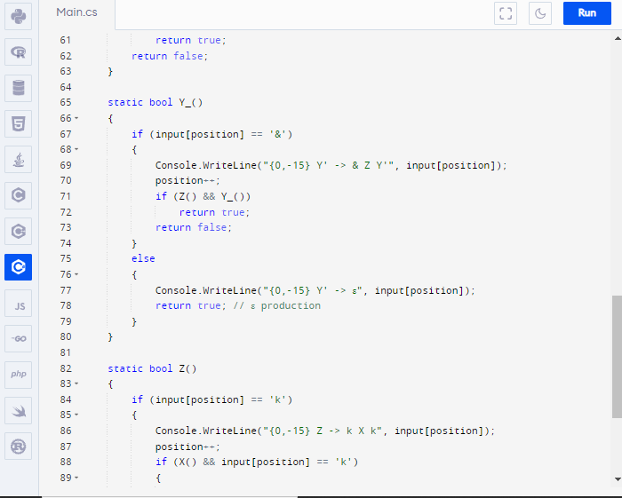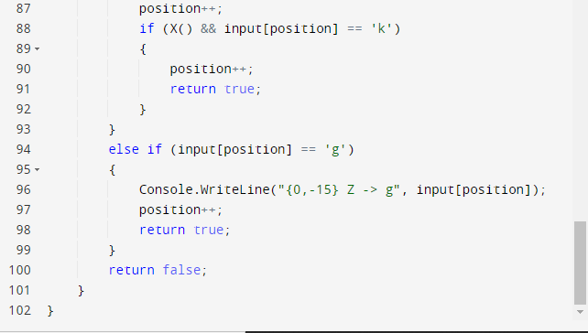

**QUESTION NO 3:**

Make a password generator according the following rules:

1. Atleast one uppercase alphabet
2. Atleast 4 numbers, two numbers must be your registration numbers
3. Atleast 2 special characters
4. Must contain initials of first and last name
5. Must contain all odd letters of your first name.
6. Must contain all even letters of your last name.

maximum length of 16 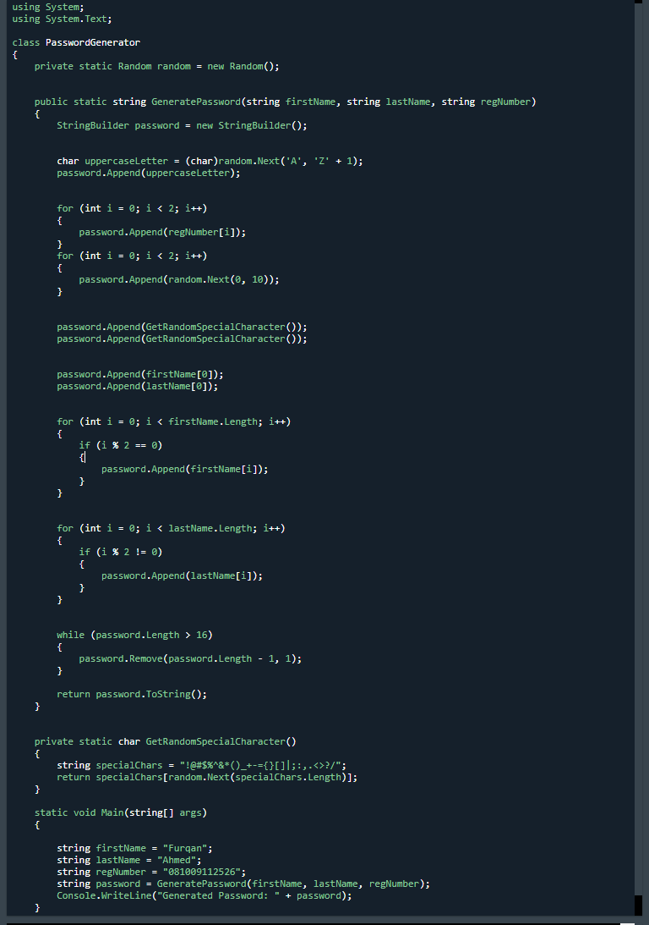

**OUTPUT:**

